CHINMAYA INTERNATIONAL RESIDENTIAL SCHOOL
COIMBATORE

SAMPLE PAPER – 2010
CLASS : 09 SUBJECT: SCIENCE

- The mode of nutrition in all fungi is
  - Symbiotic
  - Autotrophic
ANSWER
  - Saprozoic
  - Holozoic

- Identify one of the following situations where the net force acting is zero.
  - Football player kicking the football
  - A stone freely falling due to gravity
  - A fat boy pulling a small boy
ANSWER
  - A car moving at a constant speed

- The frequency of a sound is 25000 Hz. This sound is classified as
- Supersonic sound
- Infrasonic sound
ANSWER
- Ultrasonic sound
- Audible sound

- Choose the correct order of the following diagrams given below.
  - (i) Bacteria (ii) Spirogyra (iii) Euglena (iv) Chlamydomonas
  - (i) Yeast (ii) Spirogyra (iii) Chlamydomonas (iv) Euglena
  - (i) Spirogyra (ii) Oscillatoria (iii) Euglena (iv) Chlamydomona
  - (i) Bacteria (ii) Spirogyra (iii) Chlamydomonas (iv) Euglena
ANSWER
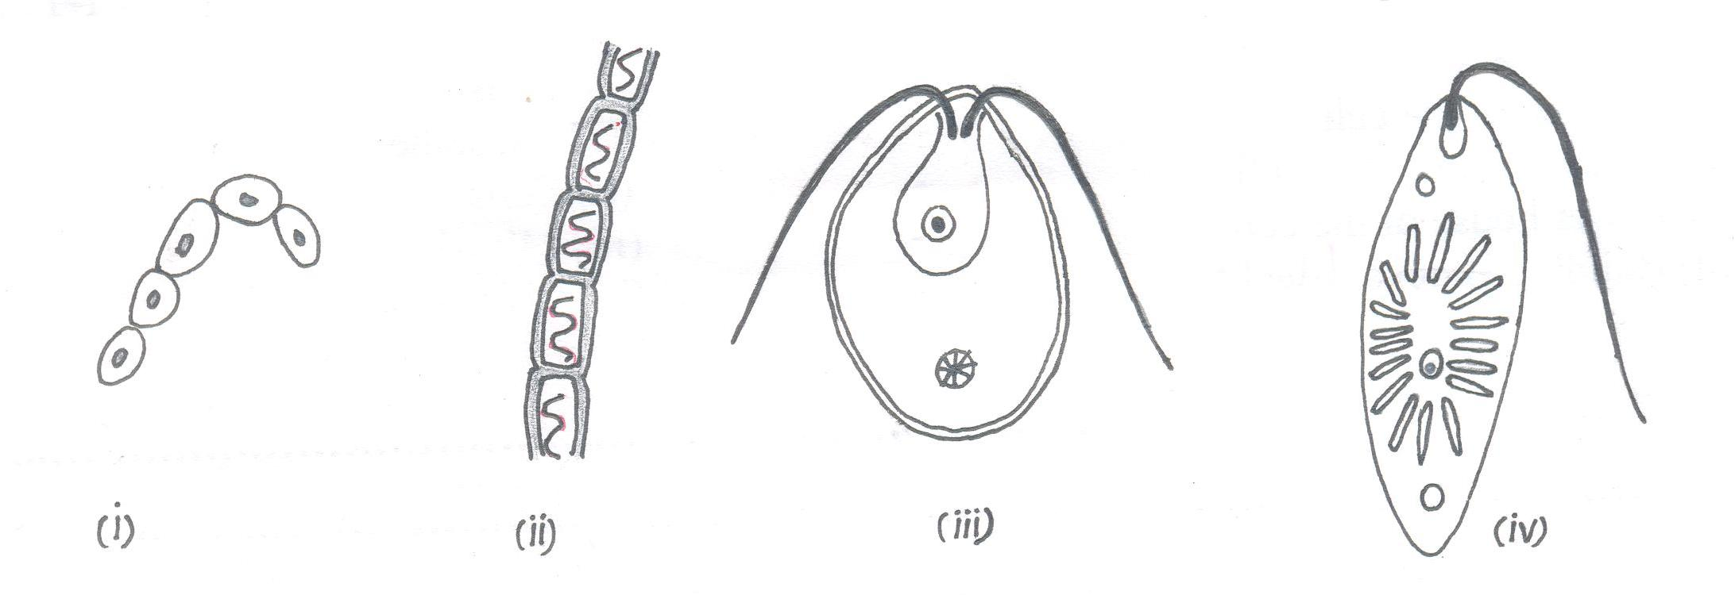

- The scientific name for the common plastic material used to make mineral water bottles is

- FET (Fine Emulsified Therepthalate)
- PVC (Poly Vinyl Chloride)
ANSWER
- High Density Polyethylene (HDPE)
- PET (Polyethylene Terephthalate)

- The fiber of which synthetic polymer was first obtained that could be stretched several times its original length?
ANSWER
A. Polyester B. Nylon C. Acrylic D. None of these

